**Supporting Information for:**

**Volcanic hazard exacerbated by future global warming–driven increase in heavy rainfall**

Jamie I. Farquharson,1,† Falk Amelung,1

1*Rosenstiel School of Marine and Atmospheric Science, University of Miami, Miami, FL, USA*

**Keywords:** Climate change; Volcanism; General circulation model; Precipitation; Geosphere–Hydrosphere interaction; Climate forcing

*Author for correspondence (jifarq89@googlemail.com).

†Present address: Independent, Edinburgh, UK

1. Contents

Figures S1–S6

Table S1

1. Introduction

This supplementary material shows:

* forced model response for all models studied assuming RCP 8.5 (**Fig. S1**);
* forced model response for all models studied assuming RCP 4.5 (**Fig. S2**);
* the breakdown of mean forced model response assuming RCP 4.5 (**Fig. S3**);
* forced model response for all models studied assuming RCP 2.6 (**Fig. S4**);
* the breakdown of mean forced model response assuming RCP 2.6 (**Fig. S5**); and
* the forced model response for each individual region and subregion for all GCMs, assuming RCP 8.5 (**Fig. S6**).

Details of models used are given in **Tab. S1**. Data were processed as described in the main text.

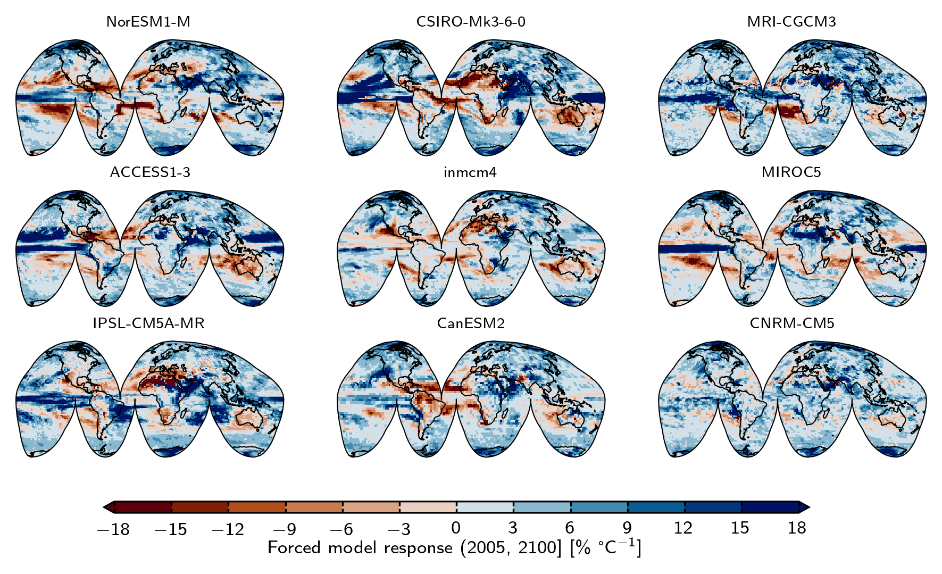  
Figure S1. Forced model response for all compared models, using model data from Representative Concentration Pathway 8.5. GCM codes (as listed in Table 1, Methods) are shown above the corresponding map. Forced model response (FMR) as *RX* versus 〈*T*〉 over the timeframe from 2005 or 2006 to 2100, normalised to 2006. Blue tones represent an increase in extreme rainfall with increased global warming, red tones represent a decrease.

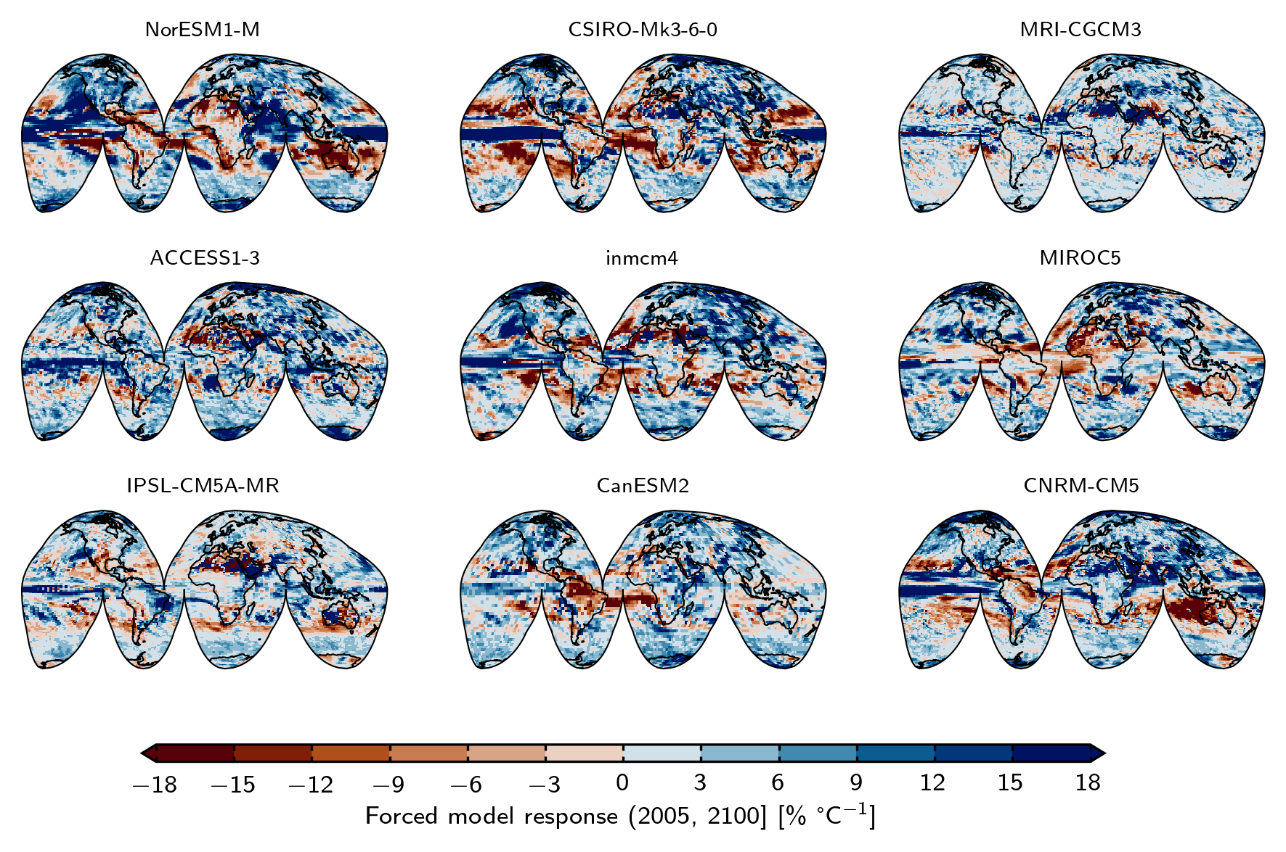  
**Figure S2**. Forced model response for all compared models, using model data from Representative Concentration Pathway 4.5. GCM codes (as listed in Table 1, Methods) are shown above the corresponding map. Forced model response (FMR) as *RX* versus 〈*T*〉 over the timeframe from 2005 or 2006 to 2100, normalised to 2006. Blue tones represent an increase in extreme rainfall with increased global warming, red tones represent a decrease.

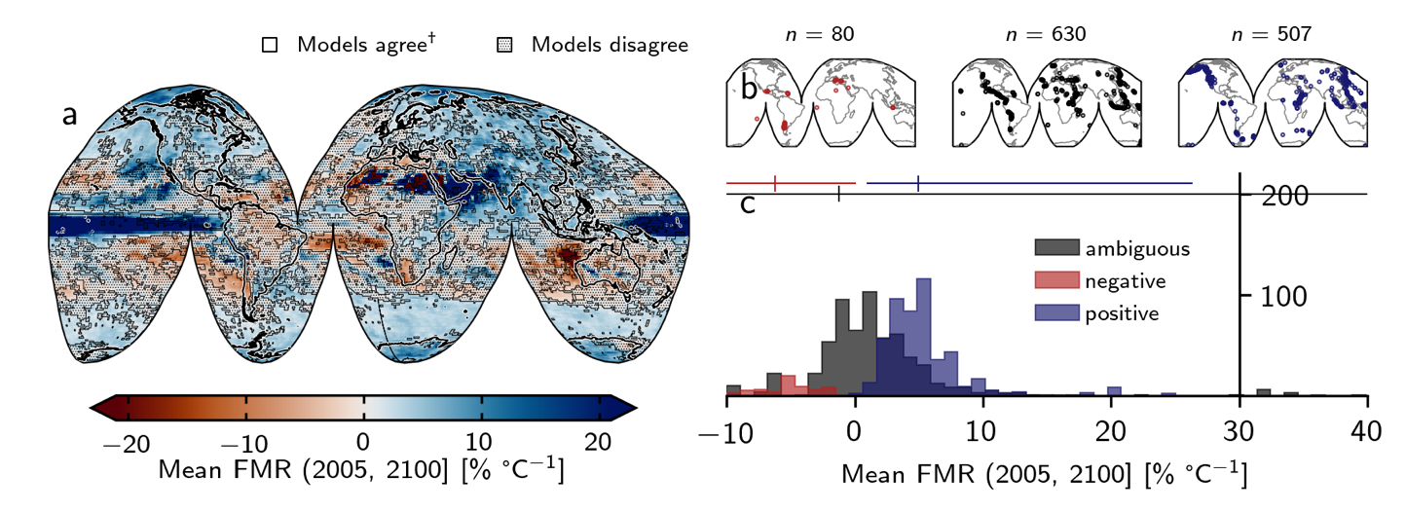  
**Figure S3**. **Breakdown of mean forced model response.** **a** Global mean forced model response (FMR) calculated from all models, based on Representative Concentration Pathway 4.5. Shaded area indicates those regions where fewer than seven of nine models agreed on the sign of change (39.54 %). †at least seven of nine models agree on the sign of change (60.46 %). **b** Subaerial volcano geolocations separated according to whether models agree on a decrease in heavy precipitation with increased warming (red: “negative”; *n* = 80); the precipitation response is ambiguous due to lack of model agreement (black: “ambiguous”; *n* = 630); models agree on an increase in heavy precipitation with increased warming (blue: “positive”; *n* = 507). *n* indicates the number of discrete Holocene-active volcanic systems in each category.  **c** Histogram of mean FMR for each group of volcanoes (as in **b**).

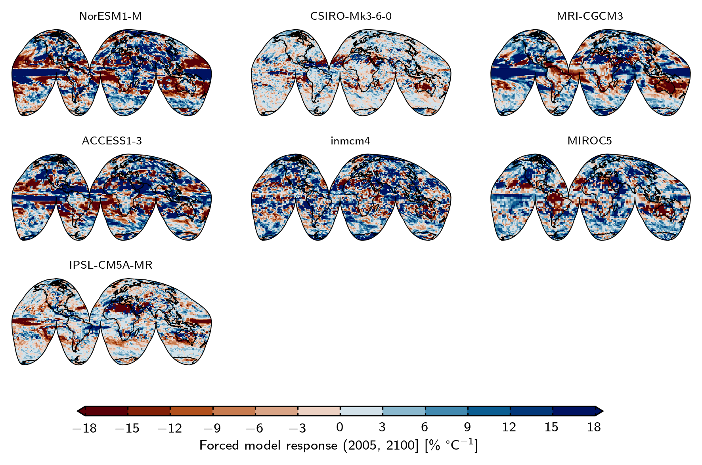

**Figure S4**. Forced model response for all compared models, using model data from Representative Concentration Pathway 2.6. GCM codes (as listed in Table 1, Methods) are shown above the corresponding map. Forced model response (FMR) as *RX* versus 〈*T*〉 over the timeframe from 2005 or 2006 to 2100, normalised to 2006. Blue tones represent an increase in extreme rainfall with increased global warming, red tones represent a decrease. 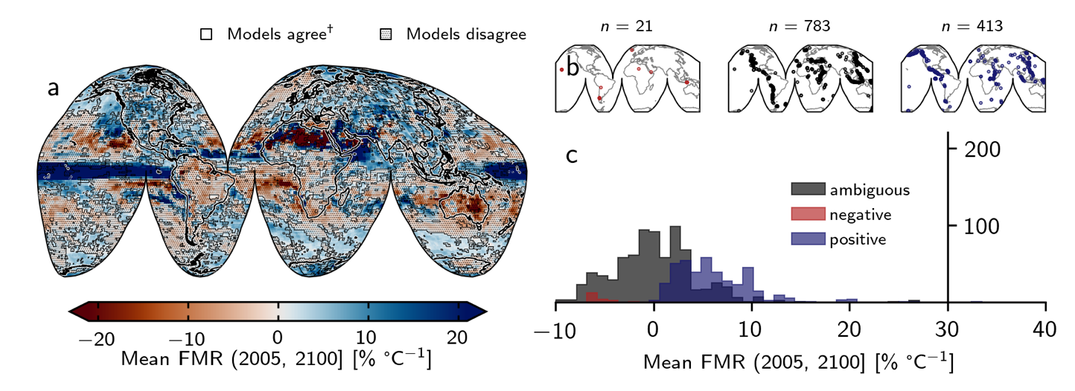

**Figure S5**. **Breakdown of mean forced model response.** **a** Global mean forced model response (FMR) calculated from all models, based on Representative Concentration Pathway 2.6. Shaded area indicates those regions where fewer than five of seven models agreed on the sign of change (53.80 %). †at least five of seven models agree on the sign of change (46.20 %). **b** Subaerial volcano geolocations separated according to whether models agree on a decrease in heavy precipitation with increased warming (red: “negative”; *n* = 21); the precipitation response is ambiguous due to lack of model agreement (black: “ambiguous”; *n* = 783); models agree on an increase in heavy precipitation with increased warming (blue: “positive”; *n* = 413). *n* indicates the number of discrete Holocene-active volcanic systems in each category.  **c** Histogram of mean FMR for each group of volcanoes (as in **b**).

**Regions**

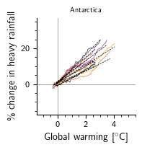 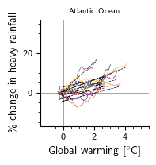 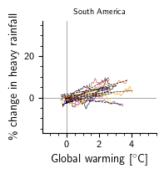 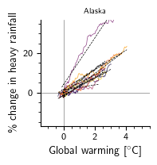 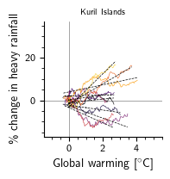 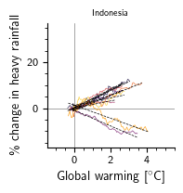 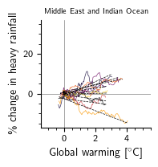 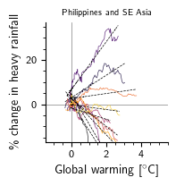 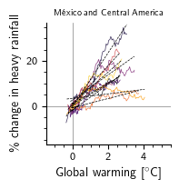 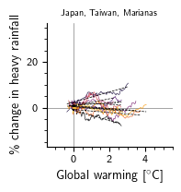 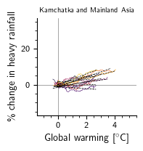 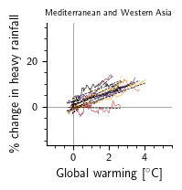 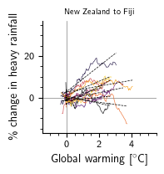 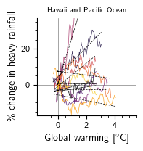 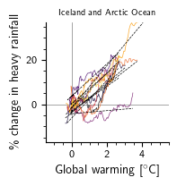 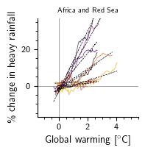 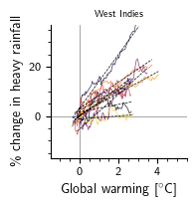 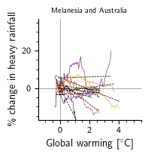 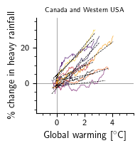

**Subregions**

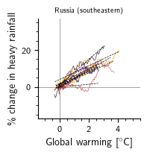 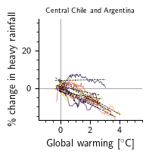 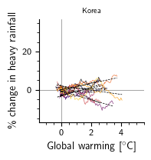 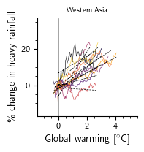 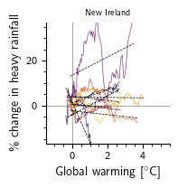 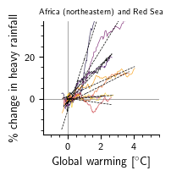 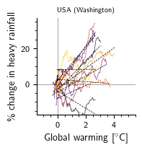 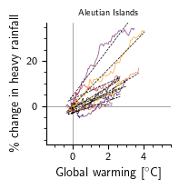 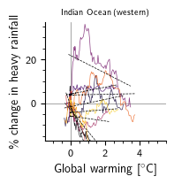 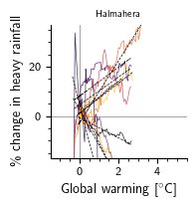 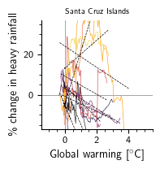 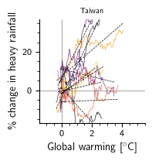 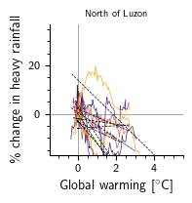 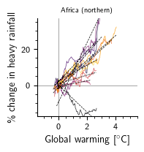 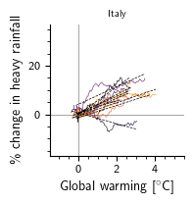 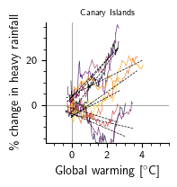 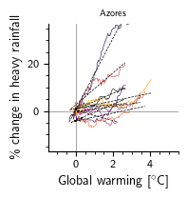 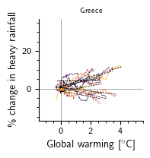 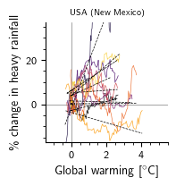 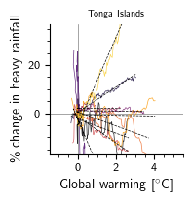 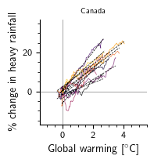 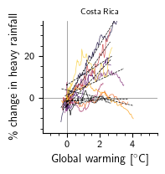 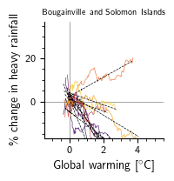 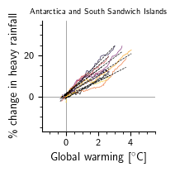 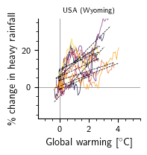 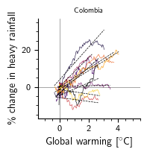 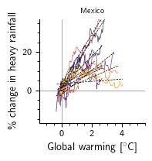 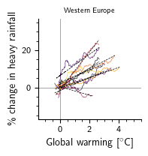 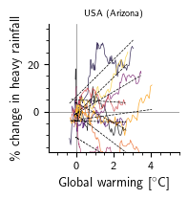 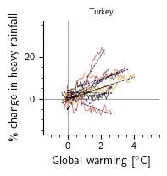 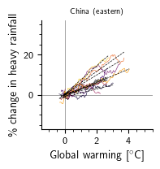 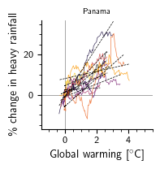 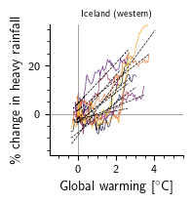 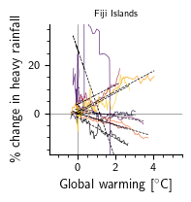 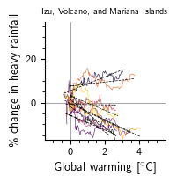 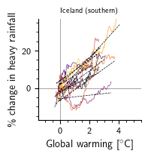 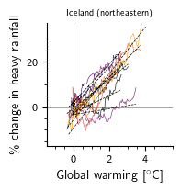  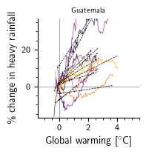 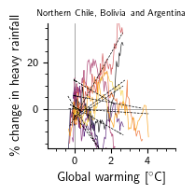 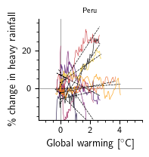  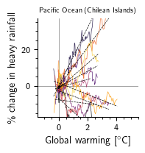 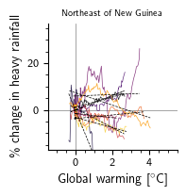 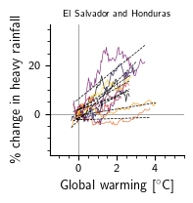 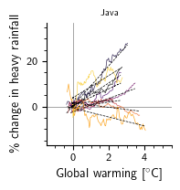 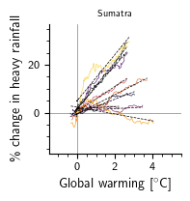 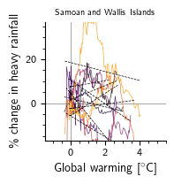 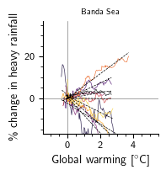 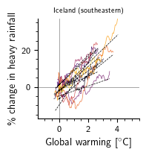 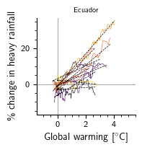 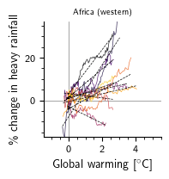 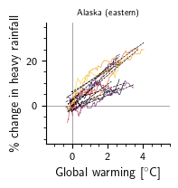 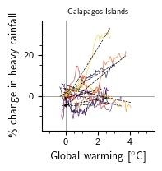 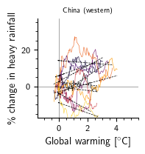 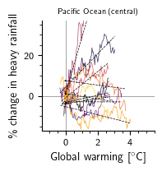 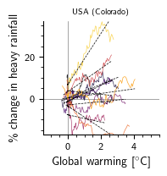  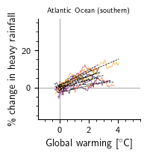 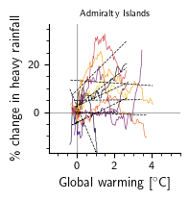 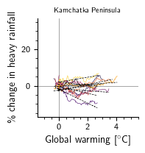 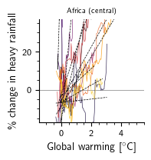 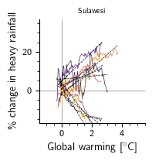 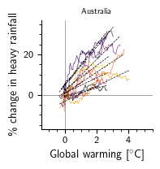 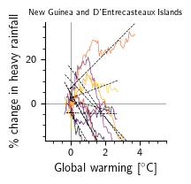 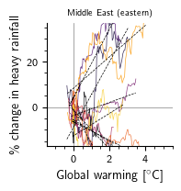 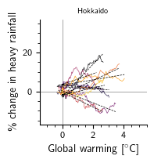 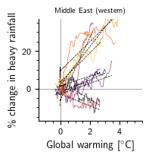 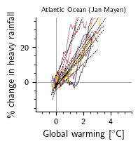 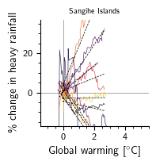 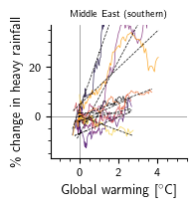 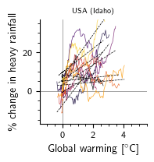 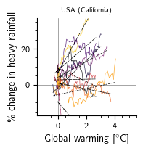 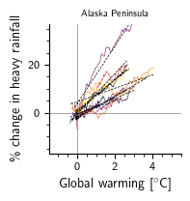 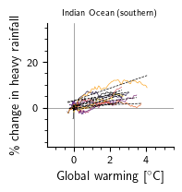 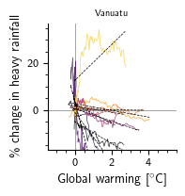 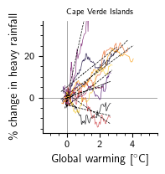 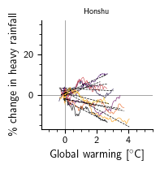 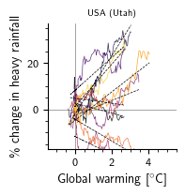 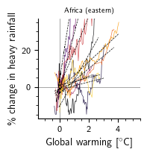 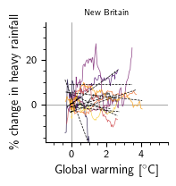 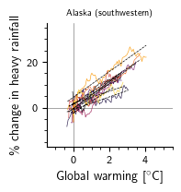 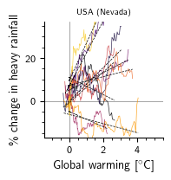 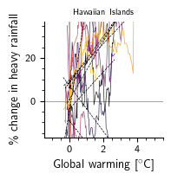 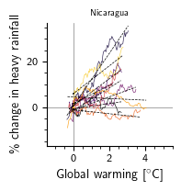 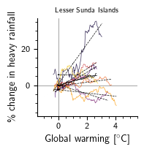 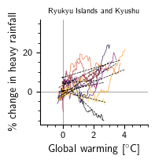 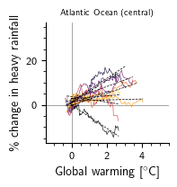 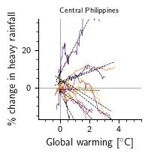 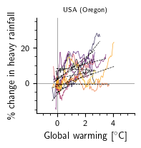 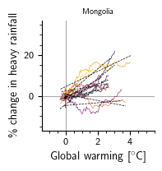 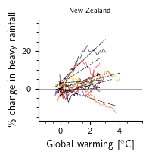 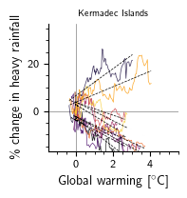 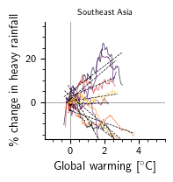 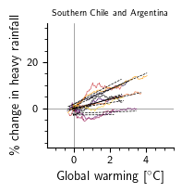 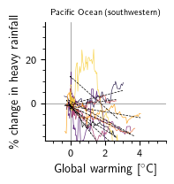 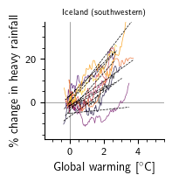 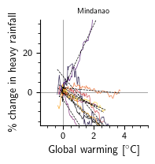 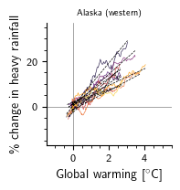 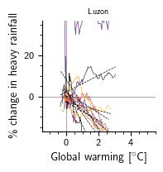 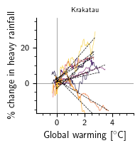

**Figure S6.** Forced model responses at different spatial scales. Percent change in modelled heavy rainfall per degree of global warming, from nine climate models: ACCESS1.3, CNRM‐CM5, CSIRO‐Mk3.6.0, CanESM2, INM‐CM4, IPSL‐CM5A‐MR, MIROC5, MRI‐CGCM3, and NorESM1‐M. Data are shown as a 30-yr rolling mean, normalized to January 2021. Dashed black lines are linear regression of response for each model. Data are areal averages, calculated by including model grids that contain a Holocene-active volcano for each of the Global Volcanism Program’s defined “Region” and “Subregion” categories (19 and 101 categories, respectively).

Table S1. Nine CMIP5 models used in this study, including their spatial resolutions. Data accessed via Earth System Grid Federation servers, in particular the node hosted by the Lawrence Livermore National Laboratory: https://esgf-node.llnl.gov/search/cmip5/.

|  |  |  |  |
| --- | --- | --- | --- |
| Model | Modelling center | Spatial resolution | |
| Nodes | Degrees (lat × lon) |
| ACCESS1.3 | CSIRO (Commonwealth Scientific and Industrial Research Organisation, Australia), and BOM (Bureau of Meteorology, Australia) | 145 × 192 | 1.25  × 1.875 |
| CNRM‐CM5 | Centre National de Recherches Météorologiques/Centre Européen de Recherche et Formation Avancées en Calcul Scientifique | 128 × 256 | 1.4008 × 1.40625 |
| CSIRO‐Mk3.6.0 | CSIRO (Commonwealth Scientific and Industrial Research Organisation, Australia), and BOM (Bureau of Meteorology, Australia) | 96 × 192 | 1.8653 × 1.875 |
| CanESM2 | Canadian Centre for Climate Modelling and Analysis | 64 × 128 | 2.7906 × 2.8125 |
| INM‐CM4 | Institute for Numerical Mathematics, Russia | 120 × 180 | 1.5 × 2 |
| IPSL‐CM5A‐MR | Institut Pierre‐Simon Laplace, France | 96 × 96 | 1.2676 × 2.5 |
| MIROC5 | Atmosphere and Ocean Research Institute (The University of Tokyo), National Institute for Environmental Studies, and Japan Agency for Marine‐Earth Science and Technology, Japan | 128 × 256 | 1.4008 × 1.40625 |
| MRI‐CGCM3 | Meteorological Research Institute, Japan | 160 × 320 | 1.12148 × 1.125 |
| NorESM1‐M | Norwegian Climate Centre, Norway | 96 × 144 | 1.8947 × 2.5 |